Whitewater Rafting Site Plan

Purpose

To create and embark on a great adventure sharing with family and friends. To give you the opportunity to feel strong sensations and have fun. And a great place to do a vacation sport activity.

Goals

* **Enhance visibility**: Create strong relationships with our customers and share information through social media about our website to make more reservations.
* **Adventures & attractions**: Display our great array of activities in our whitewater rafting such as parks, hiking, rafting, etc. In which you will be able to keep souvenirs too.

**Target Audience**

* **User personas:** First-time and experienced rafters, families and friends.
* **Challengers:** Adventurers, athletes, training reservations, outdoors and nature lovers, individuals’ excitement.

**Scenarios**

Our whitewater rafting website has all you need for good rafting and fun:

* Trip levels and difficulty: Beginner Adventure Tour

Intermediate Thrill Run

Expert Adrenaline Expedition

Sunset or Sunrise Scenic Float

Cultural + Adventure Combo

Multi-Day Wilderness Expedition

* Different options for booking a private guide or group trip
* Recommendations for activities and attractions for non-rafters
* Information concerning age restrictions and disability people
* Guaranteed security and high safety measures
* Detailed description of each aspect of the trip
* Testimonials and reviews from previous customers
* Options for customizing the trip

**Site Map**

Contact Us

About Us

Home

Book a trip

**Branding**

Logo

**Style Guide**

Color Schema

Color palette URL: <https://coolors.co/006466-007c77-fbff1f-4c1a57>

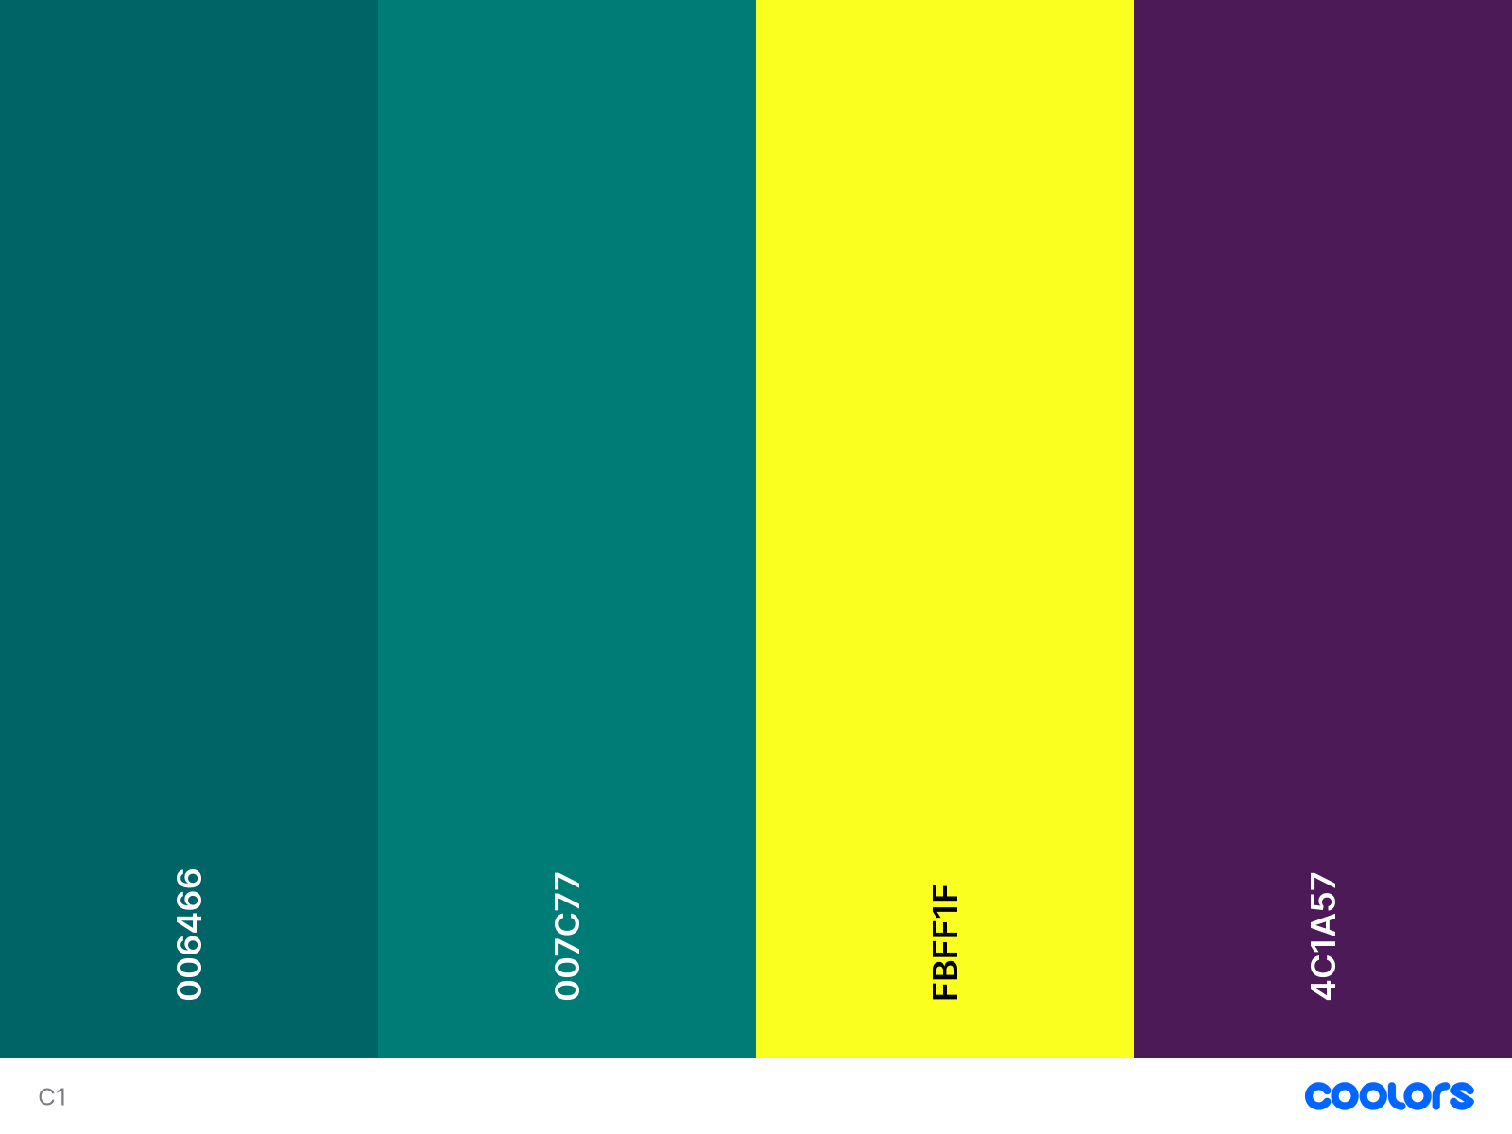

Primary Secondary Accent 1 Accent 2 Caribbean current Skobeloff Yellow Russian violet

Typography

**Heading-font**: Georgia

**Text-font**: Roboto